**Precautionary Measures to be taken in front of corona virus**

**In order to ensure that all members, employees, and beneficiaries of the various services of the office are sufficient in security and reassurance under the circumstances of the emerging virus, the following precautionary measures must be put in place by all members of the office in their various roles in order to preserve their health first and foremost:**

1. **Range of procedures:**

These procedures apply directly to:

* Regular employees of the Diakonia office in its various centers and services.
* Workers who visit Diakonia offices in various centers and services.
* Beneficiaries of Diakonia offices in various centers and services.

1. **Statement of the set of procedures:**

In January 2020, the World Health Organization (WHO) announced a new outbreak of a coronavirus in China as a public health emergency of international importance. The World Health Organization has stated that there is a high risk of coronavirus (COVID-19) spreading to other countries around the world. The World Health Organization and public health authorities worldwide are taking measures to contain the COVID-19 outbreak. However, long-term success cannot be taken for granted. All parts of our society - including us - must play a role if we want to stop the spread of this disease.

The following measures will help prevent infection from spreading in the workplace, such as colds, bedbugs and influenza, and protect beneficiaries, partners and employees.

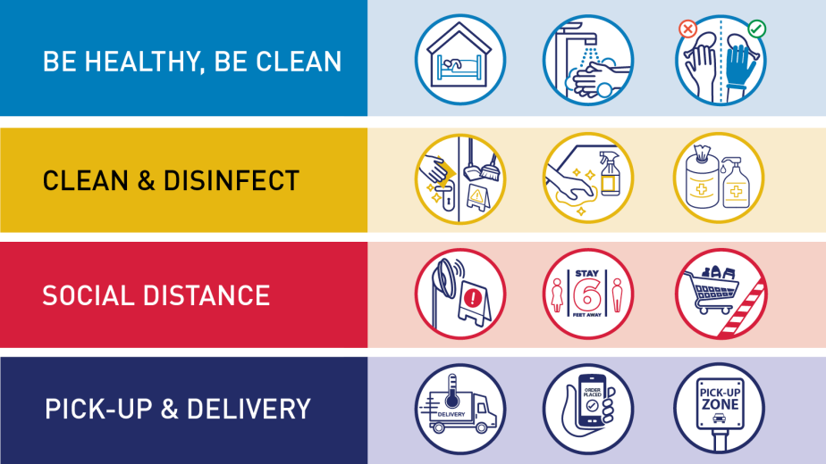

1. **The procedures to be followed when returning to work from the office:**

Below are detailed steps to help achieve the goals stipulated in the statement of procedures, including the rules and regulations to be adhered

I understand and agree to follow the following procedures:

1. Warning on the elderly workers and the owners of chronic diseases not to go to work during this period, as well as any member showing symptoms of infection
2. Not entering the work site except after conducting heat detection, wearing a muzzle and sterilization "if possible".
3. The necessity of providing the necessary disinfectants for each member
4. Make sure the workplaces are clean and healthy

* Surfaces (such as offices) and objects (such as phones and keyboards) must be wiped with disinfectant regularly.
* Whenever any members do sneezes or sudden coughs, adherence to the use of paper tissues and disposal immediately in a closed garbage bin or in the elbow fold, and then go immediately to perform high body temperature checks (above 37.5 performs household insulation procedures)
* Cleaning and disinfection of desktops, elevators and computers at least twice daily (early and midday)
* Not sharing food and personal care items with others (one-time use/disposables can only be used)
* Providing tissue paper in every office and throwing it immediately after sneezing or coughing

1. Promote regular and comprehensive hand washing by employees, managers, and beneficiaries

* Place hand sanitizer sterilizers in prominent places around the workplace.
* Ensure that these dispensers are regularly refilled
* You should avoid touching the eye, nose, or mouth
* Show posters promoting handwashing, including instructions for correct methods
* Use the necessary explanations like <https://youtu.be/x9NOUr0ItNA>
* Ensure that employees, managers, and beneficiaries have access to places where they can wash their hands with soap and water
* 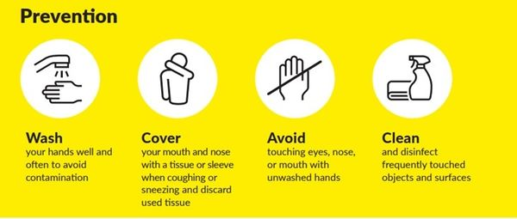Use your knees, feet, elbows and joints instead of the fingertips (for example, in opening doors)

1. Promote good respiratory hygiene in the workplace

* Show posters that promote respiratory health
* Completely prevent smoking in the workplace
* Ensure that there is adequate ventilation in the workplace
* Ensure the availability and use of face masks
* Closed garbage bins are available for healthy disposal

1. Working with the principles of social separation

* Greeting people from a distance
* Make sure to keep a distance of 1.5 or two meters between people
* Avoid direct contact with those around you at work, as well as hugging, kissing and shaking hands
* Ensure safety distance not only in offices, but also in meeting rooms
* Cancel non-essential meetings, limit their duration or number of participants, or organize them online via Skype, Teams or any other channel

1. Inform employees and beneficiaries that in the event that anyone with mild coughing or low fevers (37.3 ° C or more) need to stay at home. They must also stay home (or work from home) if they have to.

* The necessity of having a remote thermometer (not in contact with the body) and conducting a daily examination of all team members
* Continuing communication and reinforcing the message people need to stay home even if they have mild symptoms of COVID
* Show posters with this message on the premises
* Explain to employees that they will be able to consider this time as sick leave.

1. If any symptoms appearing on one of the team members, it is necessary to transfer him to home and perform PCR examinations.

* His workplace must be completely disinfected

1. If the results of his examination appear positive, the following should occur:

* Inform all team members of their possible exposure to the virus
* Obligation to stay home for everyone
* To completely close and sterilize the place for 14 days until the expiration of the isolation period for the team members and to ensure that they are not injured

1. The necessary training for all team members, the following should occur:

* Correct awareness starts with team members (all people are responsible, not just cleaners)
* Provide employees with brief training on coronavirus, and inform them of preventive measures.
* Reporting need if any of the team members visited the workplace
* Also tell outside people about the procedures before you visit

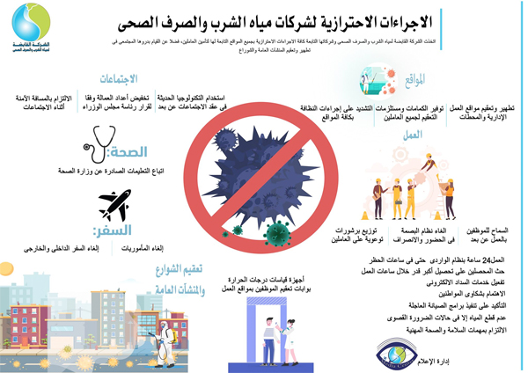

Pledge to be bound:

I hereby declare that I .............................................. ............................., I have received precautionary measures to prevent the spread of coronavirus in the workspace of the Diakonia Development Office of the Coptic Catholic Patriarchate, I have read and understood it and pledge to agree to work according to it. I understand that any failure to support these procedures may result in the termination of my work with the office or disciplinary actions.

Name: ............................................................

Center: ...........................................................

Responsibility: ................................................

Signature: .......................................................

Date: ............/........................../.......................